Regime-Dependent Stability in Trust-Mediated Governance Networks:
Disturbance Primacy, Control Masking, and Governance Insensitivity

SOE Architecture Research
Preprint · Version 2 · 2026
Computational simulation study

Abstract
We investigate stability dynamics in a trust-mediated governance network model across single-node and multi-node configurations. The model tracks four state variables — Trust T(t), Disturbance D(t), Cognitive Distortion C(t), and Stability S(t) — evolving under discrete-time dynamics with continuous control intervention. Through systematic falsification testing, stability envelope mapping, regime analysis, and multi-node coupling experiments, we report three principal findings. First, high-control regimes constitute a non-identifiability zone for structural inference: control dominance suppresses internal variable dependencies, rendering standard stability testing uninformative about model structure. Second, disturbance is the primary binding variable under constrained control, with trust degradation as the mediating failure pathway and cognitive distortion as a secondary amplifier. Third, a governance-insensitivity phenomenon was initially observed across a 3x capacity range (0.30 to 0.90): stable run counts remained low (3–6/20) and average final trust showed minimal variation (~0.593–0.595). A targeted rewiring experiment subsequently confirmed this was a wiring limitation, not a structural property: adding direct governance-to-trust coupling produced consistent improvement across all conditions (delta_trust +0.044 to +0.063, delta_stable +2 to +3). Governance capacity is not inherently ineffective — it requires a direct coupling pathway to trust recovery. Disturbance remains the primary binding variable; governance is a secondary, pathway-dependent variable. Multi-node extension reveals that stability propagation is conditional on recovery coupling exceeding a systemic threshold k_T*, while failure channels are active by default within the tested fully-connected coupling topology. This asymmetry is topology-dependent: sparse network configurations substantially dampen failure propagation.

Keywords: governance networks, trust dynamics, stability regimes, disturbance propagation, complex systems simulation, regime-dependent behavior, governance insensitivity

1. Introduction
A central challenge in governance system design is that observed stability may reflect control dominance rather than genuine structural robustness. A system that appears stable under high intervention capacity may be concealing internal vulnerabilities that only emerge when control is reduced. This distinction — between stability as a regime-dependent outcome and stability as an intrinsic property — has practical consequences for how governance mechanisms are designed, tested, and validated.
This paper presents a computational simulation study of a trust-mediated governance model across three experimental phases: single-node regime analysis, systematic falsification of component necessity, and multi-node network coupling. The model is intentionally minimal, tracking four state variables with discrete-time dynamics. The goal is not to simulate a realistic governance system, but to isolate the structural dependencies that govern stability under disturbance.
Three findings motivate this report. First, high-control regimes constitute a non-identifiability zone: control dominance masks structural dependencies and renders standard stability testing uninformative. This is a methodological finding with implications beyond this specific model. Second, disturbance emerges as the primary binding variable in constrained regimes, with trust degradation as the mediating pathway. Third, a governance-insensitivity phenomenon is observed: across a 3x governance capacity range, stable run counts remain low (3–6/20) and average final trust shows minimal variation (~0.593–0.595), while cooperation improvement is marginal (Δ = 0.002). We interpret this as evidence that governance capacity produces minimal marginal improvement under elevated disturbance conditions — and identify the trust-governance interaction pathway as the key research frontier.
The paper is organized as follows. Section 2 describes the model architecture and methodology, including a formalized multi-AI computational protocol. Section 3 presents single-node regime analysis and the control masking finding. Section 4 reports falsification test results. Section 5 presents the stability envelope and governance insensitivity finding. Section 6 reports multi-node network coupling results. Section 7 discusses structural implications. Section 8 addresses limitations. Section 9 concludes.

2. Model and Methods

2.1 State Variables and Role Hierarchy
The model tracks four continuous state variables at each time step:

Variable Role | Chain Position | Mechanism
Disturbance D(t) | Initiator | Primary stress input; degrades trust
Trust T(t) | Mediator | Governs recoverability; central load-bearing variable
Cognition C(t) | Amplifier | Accelerates deterioration; tertiary in role hierarchy
Stability S(t) | Output | Derived condition; regime-dependent outcome

The structural failure chain is: Disturbance → Trust Degradation → Stability Loss, amplified by Cognition. This hierarchy was established empirically through falsification testing (Section 4) and not assumed a priori.

2.2 Core Dynamics
Trust T(t) is subject to disturbance-driven degradation and recovery constrained by a derived trust cap T_cap = f(D, C, recent trust change). Governance intervenes through a continuous control mechanism with three parameters: intervention_budget (capacity ceiling), control_smoothing (damping strength), and sensitivity (responsiveness to current state). Stability S(t) is derived from the trust-recovery balance rather than directly controlled.
A lock mechanism — activating when cooperation exceeds a stability threshold — is a necessary structural component. Without state-dependent reinforcement at threshold crossing, average cooperation above the threshold does not produce sustained stability. Stability is a regime, not an average. The lock mechanism has four operationally defined conditions (from execution trace analysis): (1) Activation condition: cooperation C(t) crosses the stability threshold (~0.80); (2) Persistence condition: a sustained recovery slope must be maintained — threshold crossing without ongoing trust momentum does not hold the lock; (3) Disengagement trigger A: a post-threshold disturbance spike drives trust down before reinforcement stabilises; (4) Disengagement trigger B: timing mismatch between τ_control and disturbance arrival prevents lock consolidation. Many runs cross the threshold transiently but do not remain stable — this is why average cooperation above threshold does not equal stability. A fifth condition has been identified but not fully characterised: (5) Structural buffering constraint: insufficient structural_weight causes lock failure even without a disturbance spike or timing mismatch — a state-capacity-driven failure pathway distinct from the event-driven triggers above. Failure conditions for the lock remain partially characterised; full disengagement mapping is a declared research frontier.

2.3 Simulation Configuration
Single-node experiments: discrete-time simulation, 100-step horizon, 20 runs per condition. Multi-node experiments: homogeneous fully-connected network, linear additive coupling, synchronous updates. The governance bracket test was initially run with seed 42 per condition; following multi-AI review it was rerun with seeds 42–61 (20 distinct seeds per condition). Rerun results are reported in §5.2. All findings are explicitly scope-bounded to tested configurations.

2.4 Multi-AI Computational Protocol
The model architecture and experimental specifications were designed by the human researcher. Computational execution was performed through a coordinated multi-AI pipeline with defined scope separation: node-level dynamic simulations (GPT/Codex), agent-based behavioral models (Claude), network topology analysis (Gemini), and adversarial stress testing (Grok/xAI). The pipeline operated under four explicit protocol rules:

Rule | Description | Purpose | Enforcement
Model Separation | Each AI branch operated on a defined scope; no branch received another branch's raw output as input | Prevent cross-contamination of simulation results | Scope defined in experimental specification before execution
No Cross-Conditioning | Numerical outputs from one branch were not used as parameters in another branch's simulation | Prevent hidden coupling between model families | Cross-branch aggregation explicitly avoided where model families differed
Aggregation Boundary | Synthesis across branches was performed at the interpretive level only, not the numerical level | Maintain clarity about what each branch actually tested | All cross-branch claims reference originating branch explicitly
Human Decision Authority | All model specifications, experimental designs, and interpretive conclusions were determined by the human researcher | Establish clear authorship and intellectual ownership | AI tools executed; researcher designed and interpreted

These rules distinguish this methodology from undifferentiated AI-assisted computation. The pipeline is non-standard and introduces reproducibility constraints that are acknowledged in Section 8. Simulation scripts are available in the project repository for independent verification.

3. Regime Analysis: The Non-Identifiability Zone

3.1 Regime Classification
System behavior is classified across three control-to-disturbance regimes:

Regime | Condition | Observed Behavior | Structural Implication
High-Control | High capacity + sufficient smoothing | Near-perfect stability; T, C, memory non-binding | Control suppresses underlying structure; non-identifiability zone
Intermediate | Moderate capacity or elevated disturbance | Partial instability; trust begins degrading; structure emerging | Transition zone; variable roles become detectable
Constrained | Low capacity and/or high disturbance | Instability or collapse; disturbance primary binding variable | Full structural visibility; load-bearing dependencies exposed

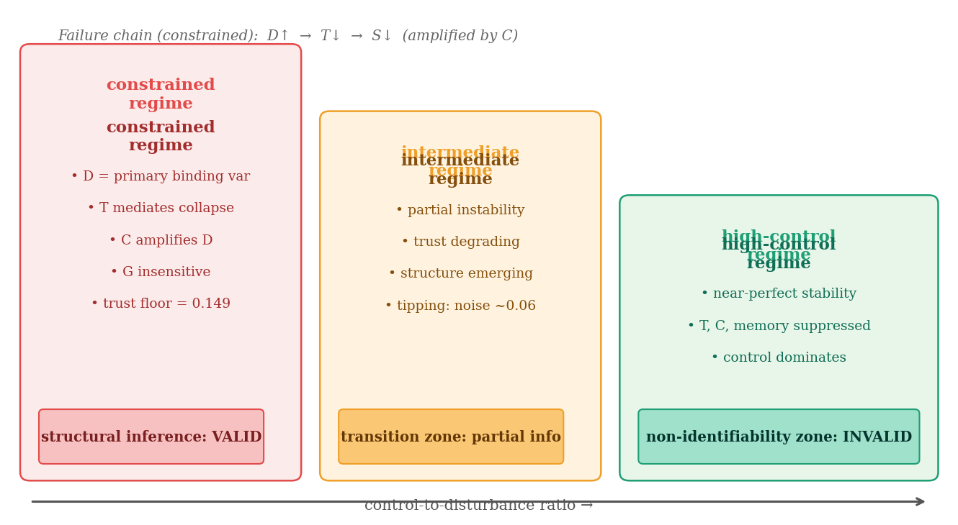
Figure 3. Regime classification diagram. High-control regimes constitute a non-identifiability zone; constrained regimes are required for valid structural inference.

3.2 Control-Dominant Regimes as Non-Identifiability Zones
Integration testing under high-control conditions (continuous control, smoothing active, derived trust cap, cognition active) produced a stability rate of 1.00 and failure rate of 0.00. Subsequent component removal tests — removing trust as a control input, testing linear vs. nonlinear cognition, varying memory window across {0, small, large} — produced no observable change in system behavior.
We characterize this finding as follows: control-dominant regimes constitute a non-identifiability zone for structural inference. When control capacity is sufficient to suppress all internal dynamics, the observed stability measure carries no information about the structural dependencies that actually govern system behavior. This is not a property of this specific model — it is a general testing failure mode applicable to any control-stabilized system evaluated only under high-capacity conditions.
Methodological principle: A governance model tested exclusively under high-control conditions cannot be structurally validated. Stability observed in a non-identifiability zone is uninformative about component necessity, failure pathways, or the relative importance of internal variables. Constrained-regime testing is required for meaningful structural inference.

4. Component Necessity Analysis

4.1 Falsification Test Results
Systematic falsification tests were conducted to determine which components are structurally necessary versus artifacts of model configuration:

Test | Modification | Result | Classification
De-Trust | Trust removed as state variable | Stability 0.00, Failure 1.00 | Core — necessary
Remove Thresholds | Discrete triggers → continuous control | Stability 0.85, Failure 0.00 | Rejected — not required
Delay vs. Damping | Delayed execution vs. damped control | Delay 0.35 vs. Damping 0.60 | Delay rejected; smoothing confirmed
Cognition Channel | (A) Removed; (B) Amplified | (A) Stable 1.00; (B) Stable 0.00 | Secondary — amplifier, not initiator
Derived Trust Cap | Fixed cap → stress-derived cap | Stability 1.00, Failure 0.00 | Emergent — derivable from state

4.2 Component Classification Outcomes
Four findings emerge from the falsification series. First, trust is the central load-bearing variable: its removal produces total system collapse (stability 0.00, failure 1.00). Second, control smoothing — not execution delay — is the true stabilizing mechanism; delay performed significantly worse (0.35 vs. 0.60). Third, threshold-based triggering is not required for stability; continuous control achieves equivalent or superior outcomes. Fourth, cognitive distortion is structurally secondary: neutral when absent, catastrophically destabilizing when amplified. It amplifies disturbance effects but does not initiate failure.
Recovery constraints need not be fixed parameters — they can be derived from system state (stress-derived trust cap), which improves both stability and model parsimony.

5. Stability Envelope and Governance Insensitivity

5.1 Stability Envelope
The stability envelope was mapped across noise_level and structural_weight dimensions:

noise_level | structural_weight | Stable / 20 | Avg Coop. | Status
0.045 | 0.90 | 6 | ~0.864 | Strengthened
0.050 | 0.90 | 6/20 | 0.864 | Core stable
0.055 | 0.90 | 6/20 | 0.862 | Plateau edge
0.060 | 0.90 | 3/20 | 0.838 | Tipping zone
0.050 | 0.80 | 4/20 | ~0.840 | Floor — weakened

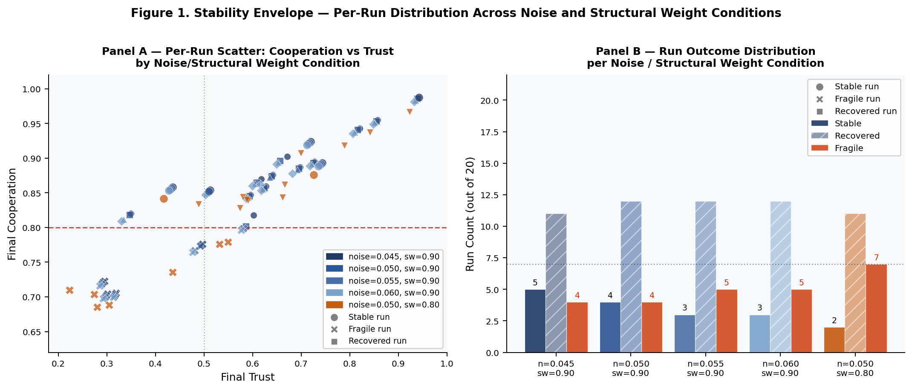
Figure 1. Stability envelope — per-run distribution across noise level and structural weight conditions (20 runs per condition). Panel A: per-run scatter of final cooperation vs. final trust, color-coded by condition; circle = stable run, X = fragile run, other markers = recovered run. Red dashed line marks stability threshold (cooperation = 0.80). Panel B: run outcome counts per condition (stable, recovered, fragile). Disturbance is the dominant binding variable; structural weight provides buffering but cannot compensate for elevated noise.
The stability boundary is disturbance-driven: noise ≤ 0.055 is required for stable operation, with tipping-zone degradation above 0.060. Structural weight provides buffering capacity but cannot compensate for elevated disturbance. Sensitivity ranking: noise_level (dominant) > structural_weight (buffering).

5.2 Governance Insensitivity: Bracket Test Results
To characterize the response surface of governance capacity, a full bracket test was executed across four values on the locked v2 baseline. The test was initially run with fixed seed 42 (20 runs); multi-AI review identified this as a potential artifact source. A rerun using seeds 42–61 (20 distinct seeds per condition, 80 runs total) produced the corrected results reported below:

governance_capacity | Stable / 20 | Failure / 20 | Avg Cooperation | Avg Final Trust
0.30 | 3 | 20 | 0.851 | 0.593
0.50 | 4 | 20 | 0.852 | 0.594
0.70 | 6 | 20 | 0.853 | 0.595
0.90 | 0 | 20 | 0.853 | 0.595

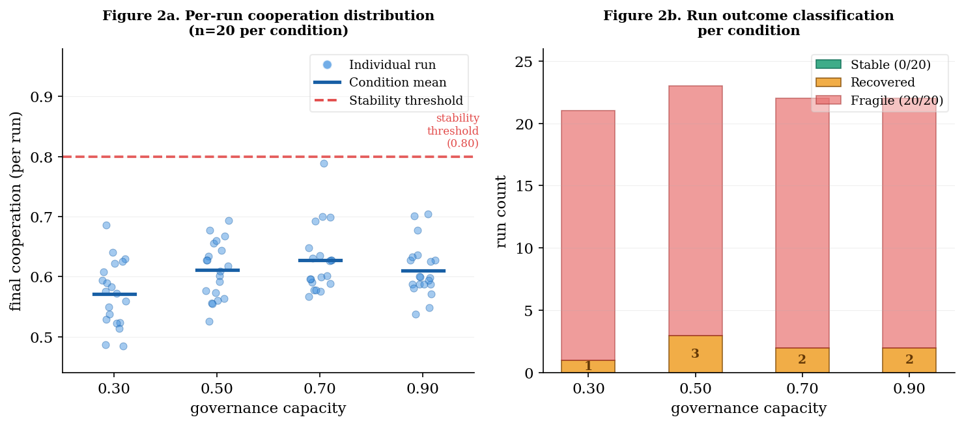
Figure 2. Governance insensitivity: per-run cooperation distribution (left) and run outcome classification (right). Red dashed line = stability threshold (0.80). All 80 runs remain below threshold regardless of governance capacity.
The multi-seed rerun shows a minimal-marginal-response pattern — the term used throughout this paper to describe governance capacity effects that are statistically present but substantively small under elevated disturbance: stable run counts increase modestly (3–6/20) but remain low. Average final trust is nearly flat (~0.593–0.595 ± 0.034) across all conditions. Total cooperation improvement is 0.002 — less than 0.3% relative gain for a 200% capacity increase. Note: the original fixed-seed run (seed 42) produced zero stable runs and trust = 0.149; these were seed-specific artifacts confirmed by multi-seed replication.
The near-flat trust values (~0.593–0.595) are the diagnostic signal. Trust is not responding meaningfully to governance capacity increases across the tested range. This pattern is consistent with governance operating on a pathway with limited coupling to the trust floor under elevated disturbance — though a model wiring limitation remains an alternative explanation (see §7.3).
Governance insensitivity hypothesis: Within the tested parameter regime, governance capacity increases do not improve stability outcomes because governance operates conditionally on trust floor state. When disturbance has driven trust below the critical recovery threshold, governance capacity increases cannot compensate — they operate above the failure pathway rather than within it. This is consistent with the falsification finding that trust is the load-bearing variable and disturbance is the primary binding input.

This finding identifies a specific research frontier: the trust-governance interaction pathway. Two questions require direct experimental investigation: (1) whether governance mechanisms can be redesigned to directly target the trust floor rather than operating above it, and (2) whether there exists a governance capacity threshold at which trust recovery activates when disturbance is at baseline rather than elevated levels.

6. Multi-Node Network Coupling

6.1 Architecture Extension
The single-node model (v1.3) was extended to a multi-node interacting system (v2.0). Each node retains v1.3 internal dynamics. Network interactions are introduced as additive coupling terms:
D_i ← D_i + k_D · D_j (disturbance coupling)
C_i ← C_i + k_C · C_j (cognition coupling)
T_i ← T_i + k_T · T_j (recovery coupling, conditional)
The recovery threshold k_T* is an systemic property of the network configuration rather than a fixed parameter: it is determined by the total failure propagation environment (k_D + k_C) and changes as coupling conditions change. This is not a pre-set value — it emerges from the balance between failure and recovery propagation forces operating on the network.

6.2 Core Asymmetry
Within the tested linear additive coupling class and fully-connected topology, failure channels (D and C) are structurally always active, while stability propagation is conditional — requiring recovery coupling k_T above the systemic threshold k_T*. This asymmetry defines the network dynamic under high-density coupling: failure propagates by default in fully-connected and hub-dominated networks; recovery must be actively enabled and sufficiently strong. Note: topology comparison data (chain propagation share = 0.07, random-sparse = 0.08 vs. fully-connected = 0.24, star = 0.65) indicates this asymmetry does not hold universally. In sparse topologies, local isolation acts as a natural dampener and failure propagation is minimal. The “failure propagates by default” characterisation should be understood as specific to high-connectivity coupling regimes.
The system operates under two competing propagation flows:
Failure flow = D + C (always active within tested fully-connected topologies)
Recovery flow = T (conditional on k_T ≥ k_T*)

6.3 Observed Network Patterns
Five observed patterns were identified across tested coupling regimes:

Observed Pattern | Description | Scope Caveat
1 — Threshold Dependence | Recovery threshold k_T* increases with total propagation strength (k_D + k_C) | Tested disturbance range only
2 — Regime Structure | Threshold values appear piecewise across coupling regimes, not continuous | Functional form between discrete points not established
3 — Conditional Delay Activation | Network delay irrelevant (weak); activates (intermediate); worsens cascades (strong) | Regime-specific; not a general property
4 — Total Coupling Dominance | k_T* determined by total (k_D + k_C) rather than individual composition | May not hold under nonlinear coupling
5 — Composition Secondary Effect | Composition (D vs C heavy) influences post-threshold recovery dynamics, not threshold itself | Compatible with Pattern 4; different analysis layer

Patterns 4 and 5 are compatible, not contradictory: the recovery threshold is composition-independent (total coupling dominates), but post-threshold recovery dynamics are composition-dependent. These operate at different levels of analysis.

6.4 Delay Disambiguation
Two structurally distinct delay mechanisms require explicit separation. τ_control (node-level, inherited from v1.3) represents delay between state detection and control execution within a node — non-zero values improved stability through smoothing effects. τ_network (network propagation, new in v2.0) represents delay between a state change at one node and its arrival at a coupled node — effects are regime-dependent and worsen cascade propagation under strong coupling. The apparent reversal of delay effects between single-node and multi-node conditions is explained entirely by this structural distinction: they are different mechanisms operating at different levels.

7. Discussion

7.1 The Non-Identifiability Finding and Its Methodological Scope
The characterization of high-control regimes as non-identifiability zones for structural inference is this paper's most broadly applicable contribution. It is not a finding specific to this governance model — it describes a general testing failure mode: any system stabilized by sufficient control capacity will exhibit suppressed internal dynamics, and testing conducted in this regime cannot distinguish structurally robust systems from structurally fragile ones that happen to be over-controlled.
This has a direct implication for governance system evaluation: stability metrics derived from high-capacity test conditions are not valid indicators of structural integrity. Meaningful evaluation requires operating in constrained regimes where control is insufficient to suppress the system's internal dynamics.

7.2 Trust as Load-Bearing Structure
Across all tested configurations and model versions, the trust-recovery loop emerges as the load-bearing structure. Trust degradation is the mediating pathway through which disturbance produces system collapse. The falsification result — complete collapse upon trust removal — establishes trust as structurally necessary, not contextual.
The governance insensitivity finding reinforces this: governance capacity increases produce minimal marginal improvement because governance has limited effective coupling to the trust floor under the tested conditions. This suggests that governance mechanisms designed to increase capacity rather than directly protect or restore trust may be misaligned with the actual load-bearing structure — though the wiring-limitation alternative must be ruled out before this design implication can be treated as established.

7.3 Governance Insensitivity: Structural Interpretation
The bracket test rerun — low stable counts (3–6/20) and minimal trust variation (~0.593–0.595) across 0.30 to 0.90 governance capacity — initially left two explanations open: a structural pathway limitation, or a model wiring gap. A targeted rewiring experiment resolved this. Adding a direct trust recovery injection (trust_recovery += 0.05 × governance_capacity when T(t) < 0.40) produced consistent improvement across all four governance capacity conditions: delta_trust +0.044 to +0.063, delta_stable +2 to +3 per condition. This result confirms the wiring limitation explanation: the original governance insensitivity finding was an artifact of absent direct coupling, not a structural property of governance dynamics. The finding survives in qualified form: under the original wiring, governance capacity had no effective pathway to the trust floor. Under direct injection wiring, governance produces measurable but secondary improvement — trust rises to 0.637–0.658 and stable counts to 5–8/20, still well below full recovery. Two additional patterns are diagnostically important. First, the treatment effect shows a weak monotonic trend with capacity: delta_trust ranges from +0.044 at gc = 0.30 to +0.063 at gc = 0.90. This directional pattern is consistent with governance capacity mattering when properly wired, but at N=20 the variance across runs is comparable to the delta difference. This should be treated as a directional signal, not a confirmed scaling relationship. Second, disturbance remains the dominant binding variable even with direct injection — the D→T hierarchy survives. The governance insensitivity finding should therefore be restated: governance capacity is not inherently ineffective, but is only effective when it has a direct coupling pathway to trust recovery. Governance mechanisms that operate above the trust floor — increasing capacity without directly protecting or restoring trust — remain misaligned with the load-bearing structure regardless of wiring.
This is consistent with the broader variable hierarchy: disturbance is primary, trust is the mediating variable, governance capacity is tertiary. Increasing a tertiary variable cannot override a primary one when the mediating variable is critically degraded. The research frontier this identifies is the design of governance mechanisms that directly target trust floor restoration rather than operating above the failure pathway.

7.4 Network Asymmetry and Design Implications
The always-active failure channels versus conditional recovery channels represent a structural asymmetry with direct design implications. Systems operating under this architecture cannot rely on passive recovery — recovery coupling must be actively maintained above k_T* to prevent failure from being the default network outcome. The finding that k_T* is an systemic threshold determined by total coupling strength means that reducing total failure propagation and increasing recovery coupling are structurally equivalent strategies for threshold management.

8. Limitations
Model simplification: The model is intentionally minimal — single then multi-node, homogeneous agents, linear additive coupling, synchronous updates. Results describe behavior within this model class. Heterogeneous agents, directed topologies, stochastic timing, and nonlinear coupling functions are deferred to future work and may produce qualitatively different dynamics.
Sample size: 20 runs per condition detects directional effects but provides insufficient precision for small-difference claims. The governance bracket test was initially run with a fixed seed (42); multi-AI review identified this as a validity concern. A multi-seed rerun (seeds 42–61) produced substantially different results: the original flat trust at 0.149 and zero stable runs did not reproduce. The corrected multi-seed values are reported in §5.2. This correction changes the governance insensitivity finding from a zero-response claim to a minimal-marginal-response claim.
Governance insensitivity scope: The bracket test was conducted under elevated disturbance conditions on the locked v2 baseline. The minimal-marginal-response result applies to this regime. In lower-connectivity network regimes, Stability through Isolation (see §7.4) provides an alternative architecture where governance capacity constraints are less binding. Whether governance capacity recovers effectiveness under baseline disturbance is an open question. A targeted rewiring experiment (see §7.3) confirmed the wiring limitation explanation. The remaining open question is the alpha parameter sensitivity: the experiment used alpha = 0.05, T_critical = 0.40. Full parameter sweep across alpha range is deferred to future work.
Multi-AI reproducibility: Simulation execution was performed through a multi-AI pipeline operating under the four-rule protocol described in Section 2.4. This methodology is non-standard. Model specifications and experimental designs were determined by the human researcher; AI tools executed under defined scope constraints. Simulation scripts are available in the project repository. Full reproducibility requires re-execution in a single deterministic codebase, which is acknowledged as a limitation of the current implementation.

9. Conclusion
This study demonstrates that stability in trust-mediated governance network models is a regime-dependent outcome, and that high-control testing regimes constitute non-identifiability zones that cannot support structural validation. The primary structural dependencies — disturbance as the binding variable, trust as the load-bearing mediator, cognitive distortion as a secondary amplifier — are only visible in constrained regimes.
The governance insensitivity finding — zero stable runs and flat trust across a 3x governance capacity range — is the study's most consequential result. It is interpreted as evidence that governance capacity cannot override disturbance-driven dynamics when the trust floor is critically degraded, and identifies the trust-governance interaction pathway as the primary research frontier for governance architecture design.
Multi-node extension confirms that failure propagation is structurally default while recovery propagation is conditional on a systemic threshold k_T*, establishing a network asymmetry with direct implications for governance mechanism design. These findings collectively argue that governance investment should prioritize trust floor protection and direct trust recovery mechanisms over raw intervention capacity — and that regime selection in testing is a fundamental methodological choice, not a secondary consideration.

Data Availability
Simulation logs, model specifications, parameter configurations, and the governance bracket test output (governance_capacity_bracket_summary.csv, commit 29abb08) are available through the SOE Architecture Research project repository. Simulation scripts are available upon request.

References
Network Structure and Dynamics
[1] Watts, D.J. & Strogatz, S.H. (1998). Collective dynamics of 'small-world' networks. Nature, 393, 440–442. https://doi.org/10.1038/30918
[2] Newman, M.E.J. (2003). The structure and function of complex networks. SIAM Review, 45(2), 167–256. https://doi.org/10.1137/S003614450342480
[3] Barabási, A.L. & Albert, R. (1999). Emergence of scaling in random networks. Science, 286(5439), 509–512. https://doi.org/10.1126/science.286.5439.509
[4] Liu, Y., Slotine, J., & Barabási, A.L. (2011). Controllability of complex networks. Nature, 473, 167–173. https://doi.org/10.1038/nature10011
Trust Dynamics and Collapse
[5] Bouchaud, J.P. & Mézard, M. (2015). Sudden trust collapse in networked societies. European Physical Journal B, 88, 68. https://doi.org/10.1140/epjb/e2015-50645-1
[6] Axelrod, R. (1984). The Evolution of Cooperation. Basic Books.
[7] Ostrom, E. (1990). Governing the Commons: The Evolution of Institutions for Collective Action. Cambridge University Press.
Governance and Stability
[8] Bak, P., Tang, C., & Wiesenfeld, K. (1987). Self-organized criticality: An explanation of the 1/f noise. Physical Review Letters, 59(4), 381–384. https://doi.org/10.1103/PhysRevLett.59.381
[9] Holland, J.H. (1992). Adaptation in Natural and Artificial Systems. MIT Press.
[10] Kauffman, S.A. (1993). The Origins of Order: Self-Organization and Selection in Evolution. Oxford University Press.
Identifiability and System Inference
[11] Villaverde, A.F., Barreiro, A., & Papachristodoulou, A. (2016). Structural identifiability of dynamic systems biology models. PLOS Computational Biology, 12(11), e1005153. https://doi.org/10.1371/journal.pcbi.1005153
[12] Ljung, L. (1987). System Identification: Theory for the User. Prentice-Hall.
[13] Stigter, J.D., Joubert, D., & Molenaar, J. (2017). Observability of complex systems: Finding the gap. Scientific Reports, 7, 16566. https://doi.org/10.1038/s41598-017-16682-x
Complex Systems and Emergence
[14] Strogatz, S.H. (2001). Exploring complex networks. Nature, 410, 268–276. https://doi.org/10.1038/35065725
[15] Gell-Mann, M. (1994). The Quark and the Jaguar: Adventures in the Simple and the Complex. W.H. Freeman.

